Future Internet Award
Announcement

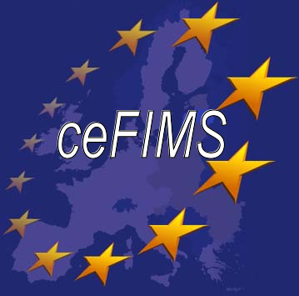

Introduction
The ‘Future Internet Award’, supported and organised by the ceFIMS Coordination Action, is an opportunity for European national and regional Future Internet initiatives to promote their work, and in particular their results. Initiatives can take the form of innovative products and services that will shape the Future Internet. The award will be presented every six months to the initiative that is adjudged to have the greatest potential to advance the Future Internet and whose results provide an exemplar for innovate products/services.
Member States and individual projects are invited to submit entries by describing in the attached application form the innovation in their work (What makes it innovative: product, service, process, etc.?).

Criteria
Entries will be adjudicated on the basis of the following criteria:
- Implementations in place
- Involvement and contacts with industry & SMEs
- Innovate use of technologies
- Inclusion of local entities, citizens, communities
- Universal usability and access
- Contribution towards reducing the Digital Divide
- Societal impacts
- Environmentally friendly
- Excellence in themed areas and/or cross-domain
- Cross-regional and/or cross-national

Entries are invited from projects and initiatives that have recently delivered final results, as well as those which are currently running.

Adjudication
A Judging Panel comprising representatives from research, industry and public agencies expert in the FI domain will judge the entries, based on the information contained in the attached application form. Further information may be sought before a final decision is made. The Award will be given to the best FI initiative in the opinion of the judges.
The winning FI initiative will be able to use the award for promotional purposes. The award will be a crystal glass vase inscribed with the location and date of the award.
Further details at: www.cefims.eu/fiaward/

Future internet award
Application Form
Completed application forms (max 3 pages) should be e-mailed to ceFIMS project manager Kieran Sullivan (ksullivan@tssg.org) by 5.00pm, Friday 16th September, 2011

PROPOSERS MAY SUBMIT SUPPORTING DOCUMENTATION BEYOND THE 3 PAGE LIMIT – HOWEVER THIS MAY NOT BE TAKEN IN ACCOUNT IN THE ADJUDICATION PROCESS

important: All information submitted should be publically available – please do not submit sensitive or confidential data, as information about the initiative will be publicised and included on the cefims website

Project Identification
Project name:
Project website:
Project coordinator name:
Contact details: (email, postal address, telephone)
Nominator name:
(if different from coordinator)

Key Information
Proposed project start (month/year):
Planned completion date (month/year):
Duration (months):

Keywords:
e.g. science, technology, health, learning, business, government, media, culture, social, entertainment, etc.

Project Abstract (maximum 10 lines):

Project Objectives (maximum 3 bullets):

Project Highlights:
e.g. describe what is innovative in your initiative; implementations in place; involvement and contacts with industry & SMEs; innovate use of technologies; environmentally friendly; excellence in themed areas and/or cross-domain; cross-regional and/or cross-national; etc.

Expected Impact:
e.g. promising technologies; products/services close to market or high potential for market uptake; contribution towards reducing the Digital Divide; societal impacts, universal usability and access, contribution in the member state, region etc.

innovative development and use of advanced internet technology:
e.g. IPv6 aware (particularly in real case settings)

Involved Constituency:
Describe the partnership and how it works e.g. end-users, public bodies (Local Authorities), industrial partners, SMEs, researchers/academia, funding agencies, citizen representative bodies, etc. Highlight any other regions / member states involved.

Total project budget:

Total budget: funding mechanism (e.g. EU: National Public: National Private: Other)

